Technical Documentation of the MVP – Trivia Game System Description
By:
Sofía Nuñez
Martín Suarez
Ignacio Cabrera
Emanuel Romero
Introduction
This document describes the technical design of the MVP (Minimum Viable Product) of a trivia game developed with Flutter and Firebase. Its objective is to clearly define how the system is designed, what functionalities it includes, how it is organized internally, and why certain decisions were made.
The documentation serves as a guide for the development team, allowing them to understand the system structure before programming it and reducing errors during implementation.
System Objective
The system's objective is to offer an interactive, scalable, and easy-to-maintain trivia game that allows users to answer questions, record scores, and improve their experience through an intuitive interface.
Additionally, this system seeks to offer an interactive and structured form of learning through a question game, combining progress and motivation mechanics.

System Requirements
The definition of requirements allows understanding what the system must do before describing its architecture, ensuring better design organization.
Functional Requirements:
The system must allow:
• Starting a trivia game.
• Displaying questions with multiple answer options.
• Recording the answer selected by the player.
• Calculating the player's score.
• Displaying results at the end of the game.
• Storing questions and answers in the database.
• Managing game logic through the game engine.
Non-Functional Requirements
The system must meet the following criteria:
• Usability: the interface must be simple and intuitive for the user.
• Performance: quick system responses. In less than two seconds.
• Scalability: ability to add more questions and features without affecting its operation.
• Maintainability: modular code to facilitate future modifications.
• Portability: the application must be able to run on different mobile devices thanks to the use of Flutter.

MVP Objective
The MVP's objective is to build a functional trivia that integrates game mechanics with clear navigation and a simple progression system, and thus we can guarantee a playable, stable, and scalable experience.
With the MVP we seek to validate the proposed architecture and the separation between logic, interface, and data.
We chose the following key functionalities:
• Node map
• Questions organized by topic
• Point system
• Simple progression
• Question anti-repetition system
Scope Justification
It was decided to limit the MVP scope to:
• Reduce initial technical complexity, avoiding overloading development with advanced functionalities.
• Prioritize the game's core: the main question and progression mechanic.
• Guarantee stability and playability, before adding more complex features (such as more characters, a store system, community questions, etc.).
• Facilitate future scalability. Leaving the architecture prepared for new functionalities.
• Achieve balance between front-end and back-end with an attractive interface and clear but simple game logic.
Functionalities Outside the MVP
• Online global ranking.
• AI-generated questions.
• Advanced store.
• Social system (users will create question topic packages)
Justification
Separating the scope allows concentrating on the game's core and avoiding overloading development with features that are not essential to validate the main idea.

Game Concept:
Start -> Node map -> Select node -> Question 1 → correct → map
→ incorrect → another question
Game States:
HOME → MAP → QUESTION → RESULT → MAP

Game Concept and State Rationale:
The design of this flow is based on three principles:
1. Cognitive Simplicity:
The player quickly understands what to do:
• Enter the game
• Choose a node
• Answer questions
• Return to the map
2. Immediate Feedback:
After each question the player receives feedback (correct, incorrect) which allows:
• Reinforcing learning.
• Maintaining motivation
• Clarifying progress
3. Progression Mental Model:
The node map is a visual representation for the player very similar to:
• Game levels
• Campaign map
• Mission system
Regarding the use of states:
We use a state model because:
a. It allows us to visualize game logic clearly
b. It facilitates implementation in Flutter through controllers or state machines
c. It reduces navigation errors
d. It allows scaling the game by adding new states (for example (Settings, Shop, Profile)
Each state represents a specific phase of the user experience:
HOME: Entry point and player context
MAP: Content selection and progression
QUESTION: Main game interaction.
RESULT: Answer evaluation
MAP: Progress guarantee
MVP Rules:
Nodes
• 20 nodes
• Each node = 1 topic
• Each node = 3 questions
Justification:
• 20 nodes: Offer enough content to generate a sense of progress without excessive complexity.
• 1 topic per node: Ensures thematic coherence and facilitates content organization.
• 3 questions per node: Balance between duration and difficulty, avoiding sessions that are too long.
Advancement Mechanic:
• Correct answer → node completed
• Incorrect answer → new question from the same node
• If you answer all three questions wrong → The game shows "Game Over", the score, and then redirects you to the main menu.
Justification:
This design avoids excessive frustration, allowing the player to keep trying without severe penalties.
Topics
Broad and popular topics were defined:
• Cinema
• Video games
• General knowledge

Justification:
• They are universal and attractive topics for a young audience.
• They allow generating a large quantity of questions.
• They facilitate future content expansion.

Each topic contains 50 questions to:
• Guarantee variety
• Avoid frequent repetition
• Support the anti-repetition system.

Point System:
• Correct answer + 10
Justification:
• Simple and easy-to-understand system.
• Allows measuring player progress.
• Can be expanded in the future (bonuses, combos, difficulty, etc.).

Anti-Repetition System:
• A question is not repeated until the topic is exhausted
• Saved in local memory
Justification:
• Improves user experience by avoiding repetitive content.
• Reduces the feeling of "cheating" or boredom.
• Does not require complex back-end in the MVP.
• Allows easy migration to remote storage in future versions.

User Stories
User stories describe functionalities from the player's point of view.
Priority Stories (MoSCoW)
Must Have (mandatory)
• As a player, I want to see a map with nodes to choose levels, to understand my progress.
• As a player, I want to answer questions with multiple options, to advance in the game.
• As a player, I want to receive immediate feedback on my answers, to learn and improve.
• As a player, I want to customize my character, to feel the game is my own.
Should Have (important)
• As a player, I want to obtain rewards when completing nodes, to feel motivated.
• As a player, I want my progress to be saved automatically, to continue later.
Could Have (optional)
• As a player, I want to adjust game settings, to adapt the experience.
• As a player, I want to see achievements or statistics, to measure my performance.
Won't Have (outside the MVP)
• As a player, I want to answer questions generated by the community.
• As a player, I want questions with different difficulty levels.
Justification
Prioritization allows defining which functions are essential for the MVP to be playable and which can be added in future versions.

System Architecture
General Description
The system is organized into three main layers:
• Presentation layer (UI): screens and widgets in Flutter.
• Logic layer: game engines and controllers.
• Data layer: Firebase Firestore and local storage.
Folder Structure
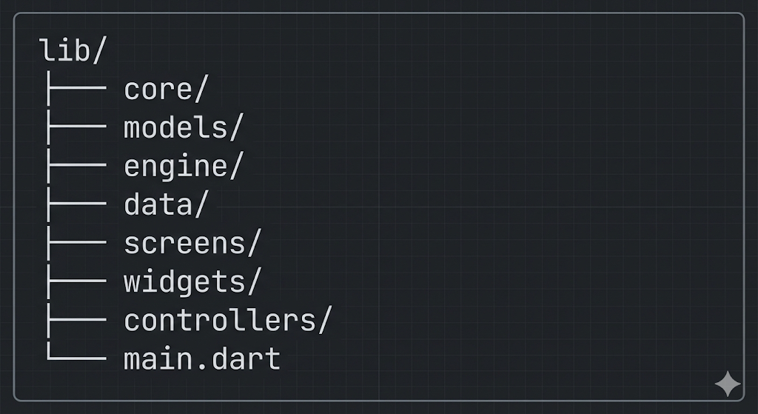
The proposed architecture separates responsibilities:
• core/: global definitions and game states.
• models/: representation of domain entities.
• engine/: main game logic.
• data/: data source.
• screens/: user interface.
• widgets/: reusable components
• controllers/: coordination between UI and logic.

MVP Screens
HomeScreen
Elements:
• character
• Play button
• player points

MapScreen
Elements:
- list of nodes (20)
- locked/unlocked nodes
- progress
Example:
[Node 1 (ready to enter)] [Node 2 (locked)] [Node 3 (locked)]
QuestionScreen
- Elements:
- question
- 4 options
- feedback (correct/incorrect)
Architectural Justification

The principle of separation of concerns is applied:
UI ≠ business logic ≠ data ≠ models
Benefits:
More maintainable code.
Facilitates testing.
Allows scaling the project.
Reduces coupling between components.
Makes it possible to migrate to more complex architectures (Clean Architecture, MVVM, BLoC).
In conceptual terms, this architecture is a simplified version of a layered architecture.

Rationale for MVP Screens
HomeScreen
Elements:
- Character
- Play button
- Player points
Justification:
- Introduces the player to the game universe.
- Allows quick access to the main action.
- Shows key information (points).

MapScreen
Elements:
- List of nodes
- Locked/unlocked nodes
- Progress indicator
Justification:
- Visually represents the player's progress.
- Generates motivation through progressive unlocking.
- Facilitates content selection.

QuestionScreen
Elements:
- Question
- 4 options
- Visual feedback
Justification:
- It is the core of the game.
- The 4-option structure is standard in trivia games.
- Feedback reinforces the interactive experience.
MVC Choice
We chose MVC because it is a clear and easy-to-understand architecture, ideal for small or medium-sized projects like our MVP.
MVC allows us to separate the system into three parts:
- Model: the data and domain logic of the game,
- View: the screens and interface,
- Controller: the logic that connects the interface with the game.
This helped us to:
- better organize the code,
- avoid mixing UI with logic,
- and prepare the project for future expansions.

Diagrams for our MVP
Use cases:
Represents the interactions between the user and the system.
Actors
• Player
Main use cases
- Start game
- Select node
- Answer question
- View result
- Obtain points
- Progress on the map
Correct answer:
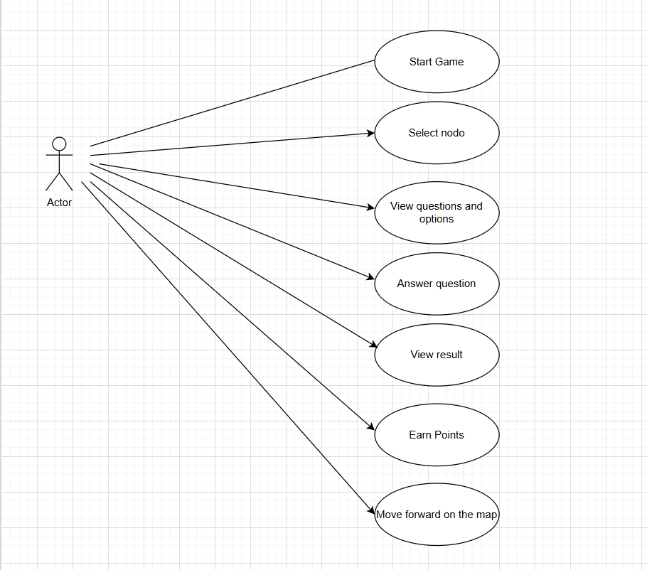
Incorrect answer:
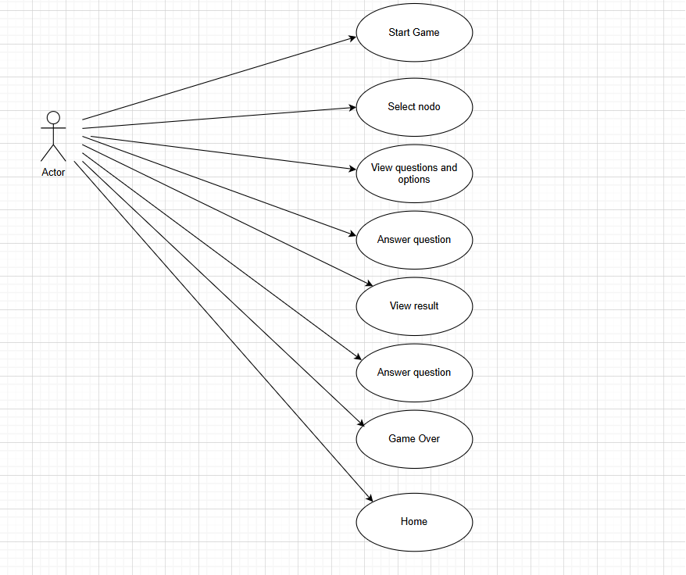
Justification:
The use case diagram allows delimiting the functional scope of the MVP and clearly defining the interactions between the player and the system.
Its objective is to identify the essential functionalities of the game and avoid the inclusion of features that are not part of the MVP's core.
Additionally, this diagram serves as a basis for architectural decision-making, as it allows prioritizing critical gameplay functionalities over secondary ones.
In this way, the system is designed from user actions, guaranteeing coherence between the game experience and technical implementation.

Class Diagram
Represents the internal structure of the system (domain model).
Main Classes:
• Player
The Player class represents the player within the system. It models the user's state and stores relevant information for the game's development.

Among its attributes are the accumulated score and the list of completed nodes, which allows measuring the player's progress within the game map.
The answerQuestion method represents the player's action when answering a question, allowing the interaction with the system to be recorded.
The inclusion of the Player class in the diagram responds to the need to separate player data from game logic, which facilitates information persistence, system scalability, and the possible incorporation of future functionalities, such as user profiles or rankings.

Player will not directly manage questions to avoid coupling between the player and game logic; GameEngine is used as an intermediary.
• Node
The Node class represents a node on the game map, understood as a unit of progress or level. Each node groups a set of questions associated with a specific topic.
Its attributes include an identifier, the associated topic, the list of questions, the completion status, and the corresponding category.
The Node class allows structuring the game map in a logical way, facilitating content organization and control of player advancement. Additionally, its existence enables the implementation of unlocking and progression mechanics.
• Question

The Question class represents a question in the trivia system. It contains the question text, answer options, the correct answer, the status of whether it has been answered, and the category to which it belongs.
The separation of the question as an independent entity allows managing game content flexibly, supporting mechanisms such as random selection and the anti-repetition system, and facilitating future expansion of the question bank.

• GameEngine
The GameEngine class represents the core of the game logic. Its responsibility is to implement the main rules of the system, manage player progress, and coordinate interaction between domain entities.
The startGame method allows initializing a new game, while updateProgress is responsible for updating the game state based on player actions, such as advancing through nodes or accumulating points.
The separation of GameEngine from other classes allows concentrating business logic in a single component, avoiding the dispersion of rules in the user interface or domain entities.
• QuestionEngine
The QuestionEngine class encapsulates the specific logic related to question management. Its responsibilities include random question selection and implementation of the anti-repetition system.
The getRandomQuestion and avoidRepetition methods allow guaranteeing that questions are presented in a varied manner and that they are not repeated until the available set is exhausted.
The existence of QuestionEngine as a separate component from GameEngine responds to the single responsibility principle, preventing the main game engine from concentrating all system logic.
• GameController:
The GameController class fulfills the role of main system controller. Its function is to coordinate the interaction between the user interface and game logic, managing system states and transitions between screens.
The handleState method allows controlling game flow, determining which state is active (start, map, question, result) and what actions should be executed in each case.
The existence of GameController allows avoiding the user interface from directly interacting with business logic, which reduces coupling and improves code organization. This decision responds to the MVC pattern, where the controller acts as a mediator between the view and the model.
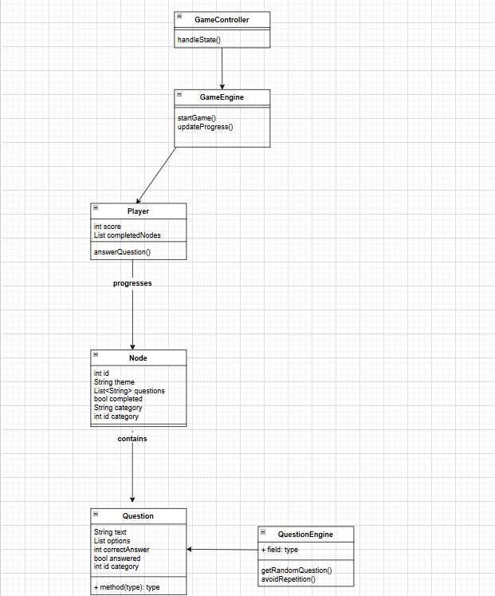
Justification:
The class diagram represents the system's domain model and defines the main entities and their relationships.
Its objective is to structure the game's data and logic in a coherent way, avoiding unnecessary dependencies between components.
The Player, Node, and Question classes represent the fundamental entities of the domain, while GameEngine and QuestionEngine encapsulate business logic.
GameController acts as an intermediary between the user interface and the system logic, following the principle of separation of concerns.
This design allows for a modular architecture, facilitates code maintenance, and enables future system extension without modifying its central structure.

State Diagram
Represents system states and their transitions
Trivia states:
1. HOME
2. MAP
3. QUESTION
4. RESULT
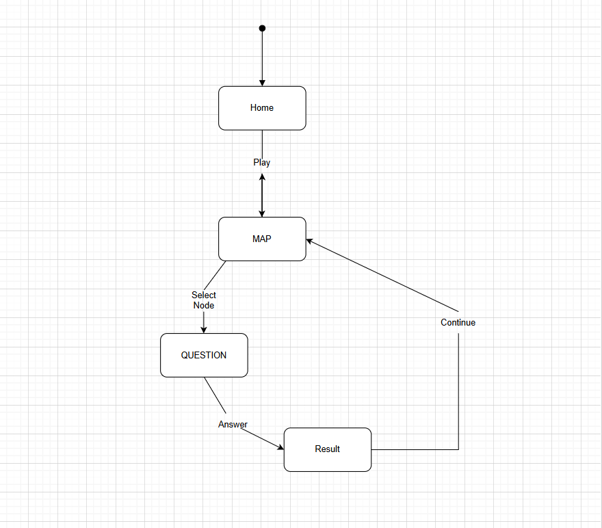
Justification:
The state diagram models the system's behavior as a finite state machine (FSM), where each state represents a specific phase of the player's experience.
We explicitly define transitions between screens, reducing the possibility of inconsistent states or erroneous navigation flows.
The use of states improves system predictability, facilitates implementation in Flutter, and simplifies testing, since each transition can be validated independently.
Additionally, this model allows easy system scaling, as new states (such as store, profile, or settings) can be integrated without altering existing logic.

Sequence Diagram:
Represents how objects interact over time.
This is the scenario, answering a question:
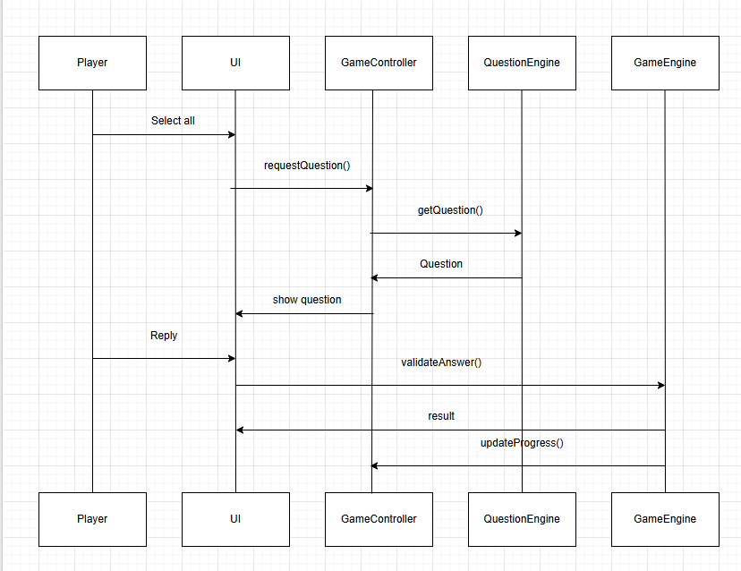
Here's the exact text translated to native US English:

Justification:
The sequence diagram describes the interaction between system components over time, showing how the user interface, controllers, and game logic engines communicate.
Its objective is to demonstrate the separation between the presentation layer and business logic, guaranteeing that the interface does not make business decisions, but rather delegates these responsibilities to the corresponding components.
This design reduces coupling between modules, improves system maintainability, and allows modifying game logic without directly affecting the user interface.

Component Diagram:
Represents the high-level structure of the system based on our folder structure
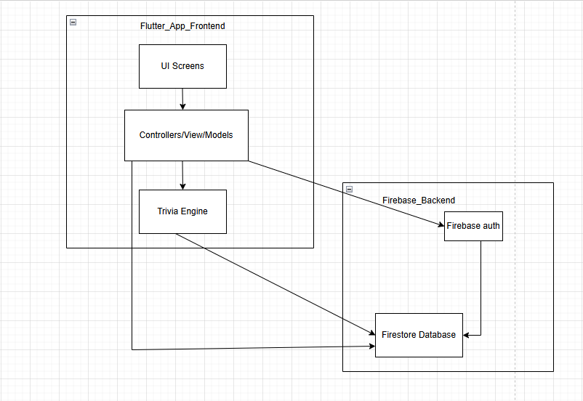
Here's the exact text translated to native US English:

Explaining the Component Diagram:
Frontend: Flutter App
UI Screens:
Responsibility: Display game screens:
• Start
• Game
• Results
• Ranking
• Settings
Justification: Separating the UI allows changing the design without affecting system logic.

Controllers/ViewModels (MVC):
Responsibility:
• Coordinate logic between UI and game engine
• Handle user events
• Communication with Firebase
Justification: Applying MVC reduces coupling between interface and business logic.

Trivia Engine (Game Engine):
Responsibility:
• Question selection
• Answer validation
• Score calculation
• Round and level management
Justification: Separating the game engine allows:
• Reusing logic
• Testing the game without UI
• Scaling the system
Backend: Firebase
Firebase Auth:
Responsibility:
• User authentication
• Login with email or Google
Justification: Avoids implementing security from scratch and guarantees scalability.

Firestore Database:
Responsibility: Store:
• Questions
• Users
• Scores
• Rankings
Justification: It is a NoSQL database ideal for mobile apps with dynamic data.

Justification for the Component Diagram:
We chose the component diagram because it allows visualizing the modular structure of the system and the responsibilities of each part.
In our trivia, we clearly separate the frontend in Flutter, the game engine, and backend services in Firebase.
This division reduces coupling, improves maintainability, and facilitates system scalability.
Additionally, it allows us to justify the use of MVC and show how business logic does not directly depend on the graphical interface.
For the MVP we decided to simplify the component diagram and focus only on the essential components of the system.
We excluded advanced external services such as analytics or cloud functions because they are not part of the functional core of the game.
This decision responds to the MVP philosophy: validate the idea with the lowest level of complexity possible, maintaining a clear and scalable architecture.

Why Do We Use These Diagrams?
Collectively, UML diagrams allow representing the system from different perspectives: functional, structural, and dynamic.
Each diagram fulfills a specific role within the system design, contributing to a comprehensive understanding of the MVP architecture.
This combination of diagrams allows validating design decisions before implementation, reducing ambiguities, and ensuring coherence between the conceptual idea of the game and its technical implementation.

Database Design
Firestore Collections
Questions
• id
• category
• questionText
• options
• correctAnswer
Users
• id
• score
• progress
• characterCustomization (out of scope)
Justification:
The database design is proposed using Firestore as a document-oriented NoSQL database. The proposed structure responds to the trivia MVP requirements, prioritizing simplicity, scalability, and query efficiency.
Two main collections were defined: Questions and Users. This separation allows clearly differentiating between game content and player state, following the principle of separation of concerns in data design.
Questions is a separate collection to allow reuse of questions between nodes and avoid data duplication.

Internal API Specification
For the trivia MVP, internal endpoints are defined that structure communication between game logic, user interface, and Firebase services. These endpoints do not represent a public API, but rather an internal organization layer of the system.
Defined Endpoints
• Get question
Allows requesting a new question from the data system or from the game's internal logic.
• Validate answer
Allows verifying whether the answer selected by the player is correct or incorrect.
• Save progress
Allows recording player advancement, such as accumulated points and completed nodes.

Justification
The definition of these endpoints allows organizing communication between the different system components in a clear and structured way.
Instead of each part of the system directly accessing Firebase or internal data, the main operations are centralized in well-defined functions. This facilitates code maintenance, improves project readability, and reduces integration errors.
Additionally, this organization allows the system to be easier to scale in the future. If it is decided to modify how data is obtained or how progress is saved, changes are made in one place, without affecting the entire application.
In the MVP context, this structure allows maintaining a simple but organized architecture, prepared for future expansions without unnecessarily increasing system complexity.

Rationale for Technologies Used
1) Flutter Choice
We chose Flutter because it allows us to develop a cross-platform application with a single codebase.
This means we can focus on game logic and user experience without duplicating effort for different platforms.
Additionally, Flutter is very suitable for an MVP because:
• it allows building visual interfaces quickly,
• it has good performance,
• it facilitates iteration and changes,
• and it is well integrated with Firebase.
Flutter was chosen instead of game engines like Godot because the project prioritizes question logic over complex graphics.
In summary, we chose Flutter because it allows us to move forward quickly without losing quality or growth possibilities.
2) Firebase Choice
We chose Firebase because it allows us to have a functional backend without needing to build an entire infrastructure from scratch.
For an MVP, creating a traditional backend would involve a lot of time and technical complexity: servers, APIs, databases, deployment, maintenance, etc.
Firebase offers us:
• data storage,
• authentication,
• player progress persistence,
• and future scalability.
We prefer a simple but powerful solution that allows us to concentrate on the game and not on infrastructure.
Quality Strategy (QA)
To guarantee the correct functioning of the trivia MVP, a basic quality assurance (QA) strategy was defined. This strategy seeks to detect errors early, validate the main system functionalities, and ensure a consistent user experience.
Given that it is an MVP and an academic project, simple but effective tests will be prioritized, focused on critical game functionalities.

Types of Tests
Unit Tests
Unit tests are applied to individual system components, such as game engine and question engine functions.
Their objective is to verify that each module functions correctly in isolation, for example:
• answer validation,
• score calculation,
• random question selection,
• anti-repetition system logic.
These tests will allow detecting errors in internal logic without depending on the user interface.

Functional Tests
Functional tests focus on validating that system functionalities behave as expected from the user's perspective.
Among other aspects, the following will be verified:
• navigation between screens,
• game flow (start, map, questions, results),
• interaction with nodes and questions,
• integration with Firebase.
This type of testing allows verifying that the different system components function correctly in an integrated manner.

Manual Tests
Manual tests consist of direct game execution by the development team.
They will be used to:
• evaluate user experience,
• detect unforeseen errors,
• verify game flow coherence,
• identify usability problems.
Given the MVP context, manual tests will be fundamental to validate the real behavior of the application.

Critical Test Cases
Priority test cases were defined, as they represent essential system functionalities.
Correct Answer Adds Points
It is verified that, when answering a question correctly, the system increments the player's score according to defined rules.
Three Errors Generate Game Over
It is verified that the system correctly detects the number of incorrect answers and ends the game when the established limit is reached.
No Question Repetition
It is validated that a question is not repeated until the available set within a category or topic is exhausted, ensuring correct operation of the anti-repetition system.
Progress Saving
It is verified that player progress (score and completed nodes) is saved correctly and recovered when restarting the application.

Quality Strategy Justification
The implementation of this testing strategy allows ensuring that the MVP functions in a stable and reliable manner, despite its limited scope.
The tests contribute to:
• reducing errors in critical functionalities,
• improving code quality,
• guaranteeing game flow coherence,
• validating that MVP requirements are met correctly.
In the project context, this QA strategy represents a balance between technical rigor and simplicity, appropriate for an MVP developed in an academic environment.

Work Planning:

Version Control Strategy (SCM)
• Use of Git and GitHub.
• Branches: main, develop, and feature.
• Pull requests and reviews.
Justification
Version control allows working as a team without losing changes.

Week 1: February 1 – 8
Game Core
• models (Player, Node, Question)
• question JSON
• GameEngine
• QuestionEngine

Week 2: February 8 – 15
Basic UI
• HomeScreen
• MapScreen
• QuestionScreen
• navigation
Week 3: February 15-21
Progress and points
• save points
• completed nodes
• don't repeat questions
Result: Playable MVP.

Project Risks and Limitations
We have identified various risks and limitations that may affect the scope, development time, and quality of the final product.

Limited Experience with Technologies Used:
The team is in a learning stage with Dart, Flutter, and Firebase, which can generate:
• longer development time,
• difficulties implementing certain functionalities,
• possible design or architecture errors.
However, we consider this risk is also considered a learning and technical growth opportunity.

Firebase Dependency:
The project depends on Firebase as backend and database, which implies:
• dependence on external services,
• limitations in backend customization,
• possible usage restrictions on free plans,
• difficulty migrating to another technology in early stages.
Despite this, Firebase is considered suitable for the MVP due to its ease of integration and development speed.

Question Engine Complexity:
The question engine includes functionalities such as:
• random question selection,
• anti-repetition system,
• organization by categories and nodes.
This can generate:
• increase in logical complexity,
• difficulty maintaining code,
• possible errors in game state management.

Time Limitations
MVP development is conditioned by a limited timeline, which can cause:
• reduction of initial scope,
• prioritization of basic functionalities over advanced features,
• less time for testing and optimization.

Game State Management
State handling (HOME, MAP, QUESTION, RESULT) can generate:
• navigation errors between screens,
• inconsistencies in game flow,
• difficulty debugging state-related errors.

Limited MVP Scalability
Being an MVP, the architecture prioritizes simplicity over complexity, which implies:
• limitations to support advanced functionalities in the short term,
• need for refactoring in future stages,
• possible changes in architecture design.

Content Quality and Quantity
The system depends on a manually created question bank, which implies:
• risk of repetitive or poorly formulated questions,
• limitations in content quantity,
• need for question curation and validation.

Data Persistence and Synchronization
Using local storage combined with Firebase can generate:
• inconsistencies between local and remote data,
• information loss in certain scenarios,
• greater complexity in synchronization logic.

Despite these risks, it was decided to proceed with this architecture because it allows building a functional MVP, keeping the project within a manageable scope, and laying the foundation for future improvements.
Conclusion
The documentation defines a clear structure for trivia MVP development. Technical decisions were made considering simplicity, scalability, and team learning. The proposed design allows building a functional game prepared for future improvements.

